**Introduction:**

8 modules

**Course Objectives**

* Provide an overview of the core components of the Service Management Lifecycle as described by ITIL
* Discuss the relevance of IT Service Management to your organization
* Prepare for the Foundation exam

Primary Focus:

* Service and life-cycle those service go through

**Course Schedule**

Main Topics – Foundation

* Service Lifecycle

Phases

Capabilities

Resources

Quality

* The instructor will define the expected daily content

Practice Questions

* Homework

Practice Exams

Foundation Exams

**CERTIFICATION EXAM**

* 40 Multiple Choice
* Must achieve 65% 26 correct
* 1 hour time limit

75 minutes and a dictionary is allowed for candidates sitting the exam in a language other than their own

* Candidates with passing score receive Foundation Pin and Certificate
* Enables future studies

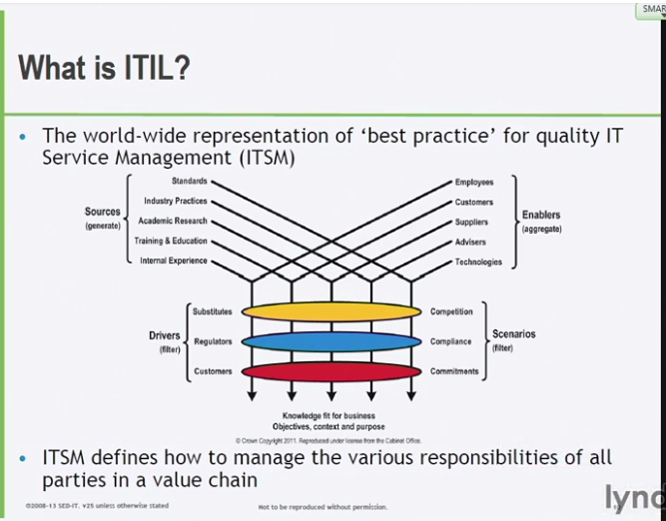

**Sources:**

* Generate good practices for SM

**Enablers:**

* *Ingredients* in order to provide good services

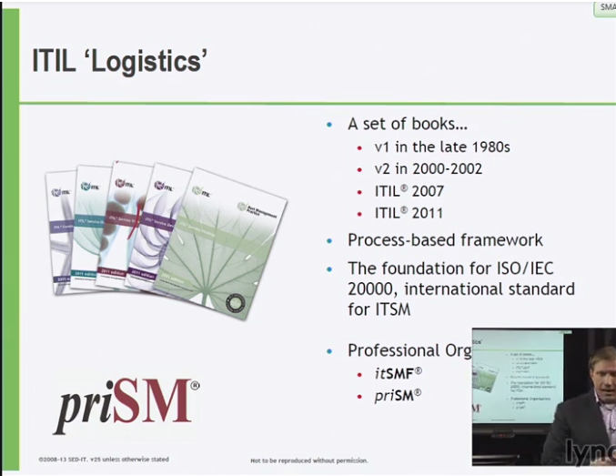

**Process-based framework**

**Foundation for ISO/IEC 20,000, international standard for ITSM**

Orgs. Become certified on ISO 20,000

**Components of the Service Lifecycle (phases) ITIL CORE**

SS (Service Strategy) - SD (Service Development) – ST (Service Transition) - SO (Service Operation) – CSI (Continual Service Improvement)

e.g. New service: Voice & Data Service : Service Strategy

**SS**

* achieve and maintain a strategic advantage to refine and create policies, guidelines, and processes that cross all of the ITIL service life cycle.

**SD**

* takes the Service Strategy, and creates the design that will eventually operationalize those business objectives.
* **We’re putting a new service in, retiring a service, and making a change**
* **What is this going to look like, metric & measurements to manage; keep track of health**
* **Solution, tools, processes**

**ST**

* provides the guidelines for development and improvement of capabilities for transitioning new and changed services into the life service operation.
* **Activities to put that in or retire that or make those changes**
* **Approving changes, deploying new releases, capturing knowledge; transitioning new service into live environment**

**SO**

* manages the day-to-day operation of a service and provides guidelines on the effective and efficient delivery and support.
* **Run & support**

**CSI**

* provides critical guidelines in creating and maintaining value for customers through better design transition and operation of services
* **Improve monitor/measure metrics**
* **Improvement perspective**

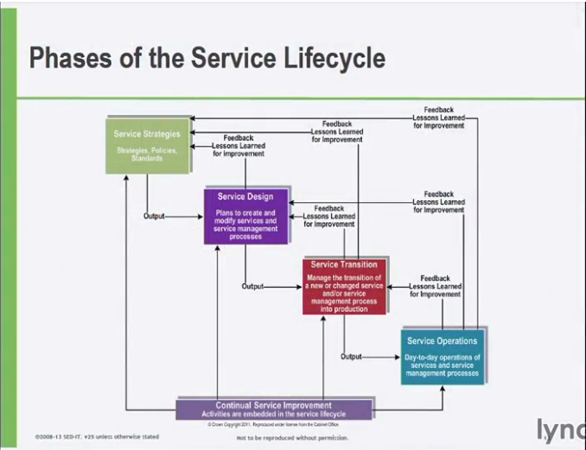

**SS**

* Processes
* Value creation
* Business Case
* **Governance & Decision-making**

**SD**

* Processes
* 5 Aspects of Service Design
* RACI, SDP, 4Ps of Service Design
* **Building structural service integrity**

**ST**

* ­Processes
* SKMS, CMS
* Managing risk, complexity
* **Preparing for change**

**SO**

* Processes and Functions
* Communication

**CSI**

* Process
* CSI Register
* PDCA Model
* Continual Service Improvement Model
* Baselines
* Types of metrics
* Measurement
* **Increase efficiency, maximize awareness, optimize cost of service**

**Service Knowledge Management Service**

* **Central: Glues all processes together**
* **Consistent knowledge/wisdom**
* **Collecting, storing, having knowledge for recall**

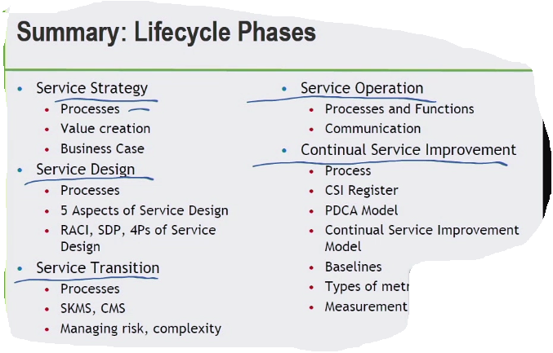

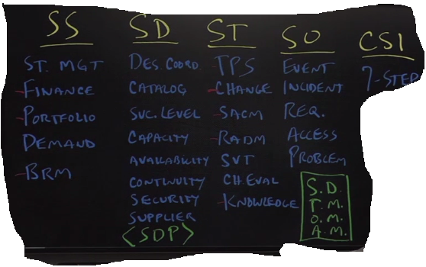

**5 aspects of SD**

* STAMP, service solutions, tools, architecture, metrics, **measurements**

**SDP –** Service Design Package

**5 P’s** – People process products partners

**TPS –** Transitioning Planning and support

SACM – Service Asset Configuration Management

RADM – Release and deployment management

SVT – Service Validation and Testing

Change Evaluation

**Service Knowledge Management System(SKMS)**

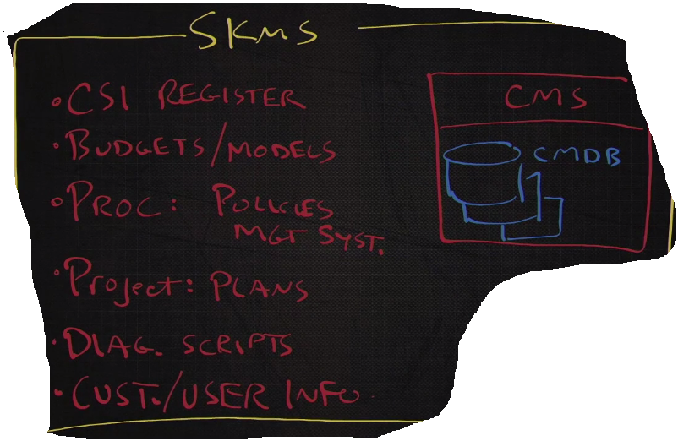

**CMS - Configuration Management System**

* **One or more cmdb**